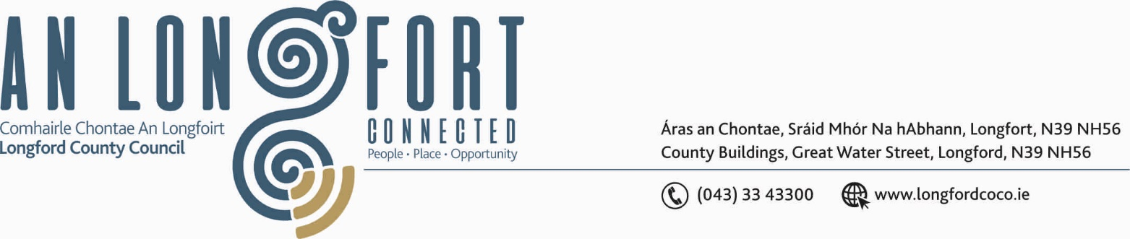

BALLYMAHON MUNICIPAL DISTRICT

Please note change of time of meeting to 4.30 p.m.

20th July 2018.

To: Each Member of Ballymahon Municipal District.

Dear Member,

You are requested to attend Meeting of Ballymahon Municipal District to be held in Ballymahon Community Library on Thursday, 26th July 2018 at 4.30 p.m. to transact business, as set out on the Agenda hereunder.

Yours sincerely,
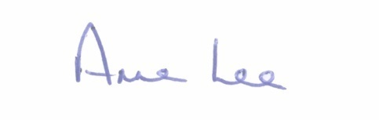

_______________
Anne Lee,
Meetings Administrator.

AGENDA

Prayer before meeting.

1. Confirmation of Minutes of the following Meetings of Ballymahon Municipal District -

- Committee Meeting held on the 3rd May 2018
- Municipal District Meeting held on the 3rd May 2018.
- 2018 Annual Meeting held on the 21st June 2018.
- copies enclosed.

2. Matters arising from Minutes.

3. Management Report - enclosed.

4. Community Grant Support Scheme 2018.

5. Consideration of Report on Burial Grounds - enclosed.

6. Upgrade of Amenities.

7. Notices of Motions submitted by Councillors, as listed hereunder –

Councillor Paul Ross.

“In the interest of public safety, that speed ramps be installed at Smithfield Cresent Housing Estate, Legan.”

“That Longford County Council request Irish Water to upgrade the sewerage treatment and waste water plant at Ballymahon which is now at capacity in order to ensure further population, commercial and economic growth in the town.”

Councillor Colm Murray.

“I call on Longford County Council to install solar powered speed signs on the entrance each side of KenaghVillage along the R397.”

“I call on Longford County Council to facilitate the setting up of a Town Team in Kenagh”

Councillor Gerard Farrell.

“In light of the new policy on speed detection signs, I call on Longford County Council to put one up on the Ballymahon Road in Lanesboro.”

“I have reason to believe that there might be a danger of losing the Community Welfare Officer on Lanesboro. I wish to write to the Department to oppose such a move for any such service in South Longford”

8. Correspondence.

- To note letter dated 20th April 2018 received from the Department of Agriculture, Food and Marine regarding the Control of Noxious Weeds on Public Lands - enclosed.

